Test Execution Details
Test Case ID

TC_LOGIN_001

Requirement ID

REQ_LOGIN_01

Module Name

Login Module

Feature Under Test

User Authentication

Test Scenario

Login with valid and invalid credentials

Test Objective

To verify successful and unsuccessful login for different username and password combinations.

Test Type

System Testing

Test Technique

Black Box Testing

Priority

High

Severity

Critical

Preconditions

User account exists and Login application is available.

Postconditions

User is either logged in successfully or login failure is displayed.

Test Environment

QA Environment

Browser/OS

Chrome / Windows 11

Tester Name

Janvi Patel

Scenario 6a

Scenario ID: 6a

Scenario: Login with Valid Username and Valid Password

Test Steps:

1.Open the Java Login application.
2.Enter Scenario ID 6a.
3.Verify the username and password.
4.Run the test.

Test Input:

Username: admin, Password: Admin123

Expected Result:

Login Successful should be displayed.

Actual Result:

Login Successful displayed.

Status:

PASS
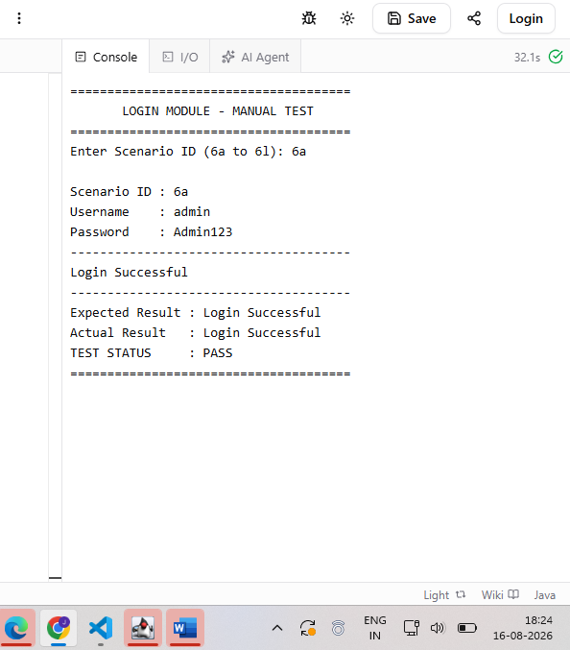

Scenario 6b

Scenario ID: 6b

Scenario: Login with Valid Username and Invalid Password

Test Steps:

1.Open the Java Login application.
2.Enter Scenario ID 6b.
3.Verify the username and invalid password.
4.Run the test.

Test Input:

Username: admin, Password: Wrong123

Expected Result:

Login Failed should be displayed.

Actual Result:

Login Failed displayed.

Status:

PASS
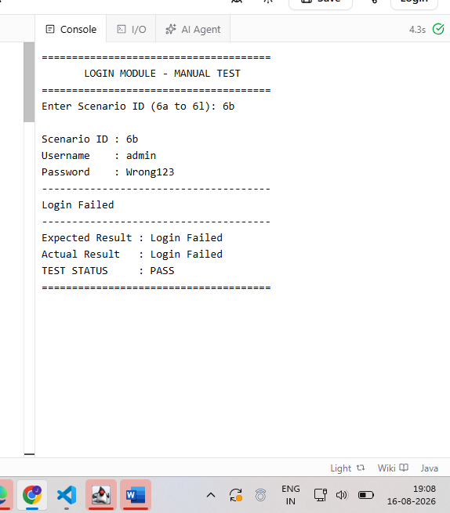

Scenario 6c

Scenario ID: 6c

Scenario: Login with Invalid Username and Valid Password
Test Steps:

1.Open the Java Login application.
2.Enter Scenario ID 6c.
3.Verify the invalid username and valid password.
4.Run the test.

Test Input:

Username: user123, Password: Admin123

Expected Result:

Login Failed should be displayed.

Actual Result:

Login Failed displayed.

Status:

PASS

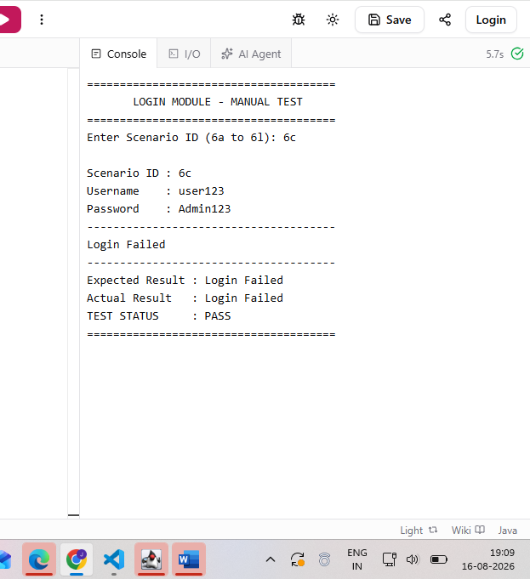

Scenario 6d

Scenario ID: 6d

Scenario: Login with Invalid Username and Invalid Password

Test Steps:

1.Open the Java Login application.
2.Enter Scenario ID 6d.
3.Enter invalid username and invalid password.
4.Run the test.

Test Input:

Username: user123, Password: Wrong123

Expected Result:

Login Failed should be displayed.

Actual Result:

Login Failed displayed.
Status:

PASS

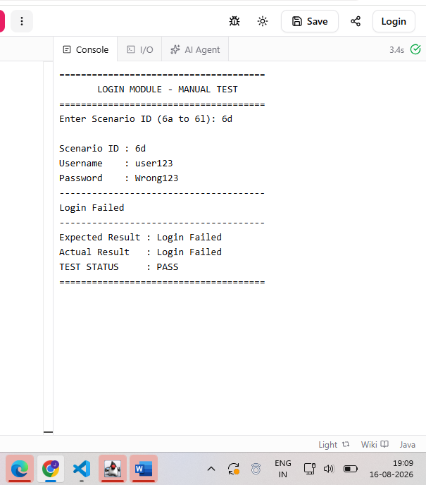

Scenario 6e

Scenario ID: 6e

Scenario: Login with Blank Username and Valid Password

Test Steps:

1.Open the Java Login application.
2.Enter Scenario ID 6e.
3.Verify that username is blank.
4.Run the test.

Test Input:

Username: Blank, Password: Admin123

Expected Result:

Login Failed should be displayed.

Actual Result:

Login Failed displayed.

Status:

PASS

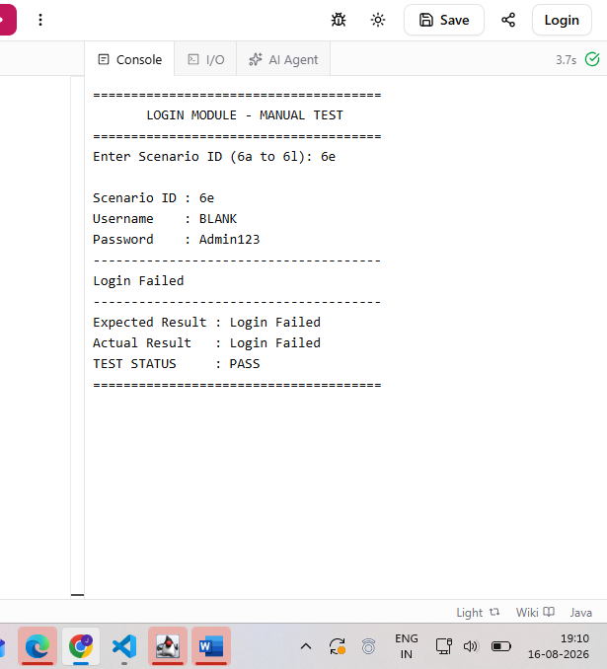

Scenario 6f

Scenario ID: 6f

Scenario: Login with Valid Username and Blank Password

Test Steps:

1.Open the Java Login application.
2.Enter Scenario ID 6f.
3.Verify that password is blank.
4.Run the test.

Test Input:

Username: admin, Password: Blank

Expected Result:

Login Failed should be displayed.

Actual Result:

Login Failed displayed.

Status:

PASS

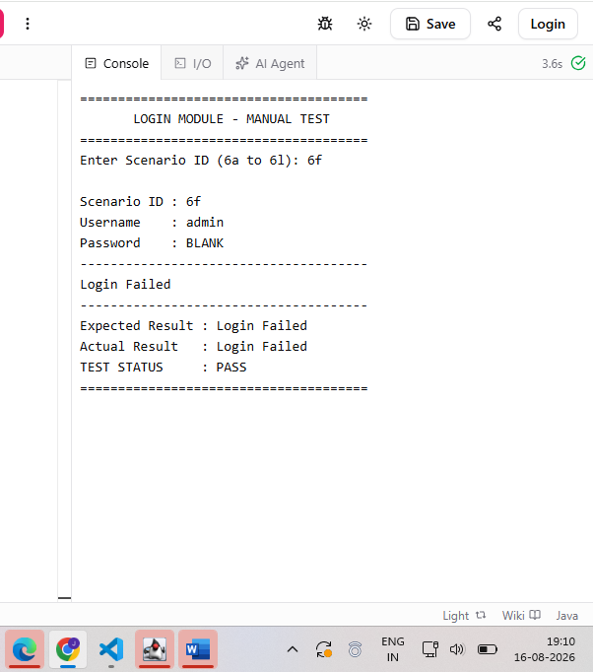

Scenario 6g

Scenario ID: 6g

Scenario: Login with Blank Username and Blank Password

Test Steps:

1.Open the Java Login application.
2.Enter Scenario ID 6g.
3.Leave username and password blank.
4.Run the test.

Test Input:

Username: Blank, Password: Blank

Expected Result:

Login Failed should be displayed.

Actual Result:

Login Failed displayed.

Status:

PASS

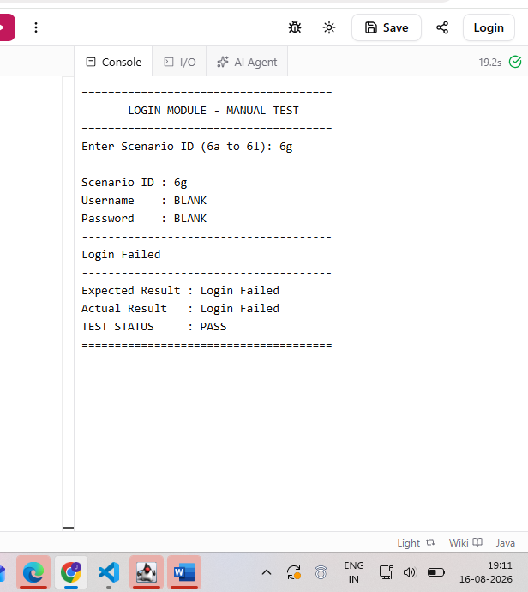

Scenario 6h

Scenario ID: 6h

Scenario: Verify Login with Valid Credentials Again

Test Steps:

1.Open the Java Login application.
2.Enter Scenario ID 6h.
3.Verify valid username and password.
4.Run the test.

Test Input:

Username: admin, Password: Admin123

Expected Result:

Login Successful should be displayed.

Actual Result:

Login Successful displayed.

Status:

PASS

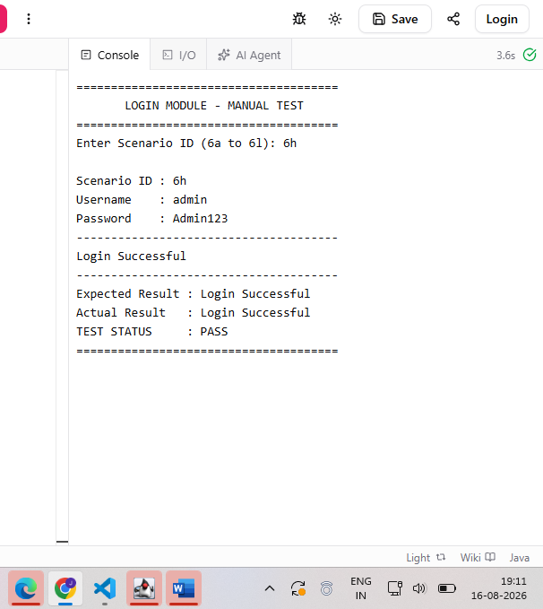

Scenario 6i

Scenario ID: 6i

Scenario: Login with Different Invalid Username

Test Steps:

1.Open the Java Login application.
2.Enter Scenario ID 6i.
3.Enter a different invalid username.
4.Run the test.

Test Input:

Username: testuser, Password: Admin123

Expected Result:
Login Failed should be displayed.

Actual Result:

Login Failed displayed.

Status:

PASS

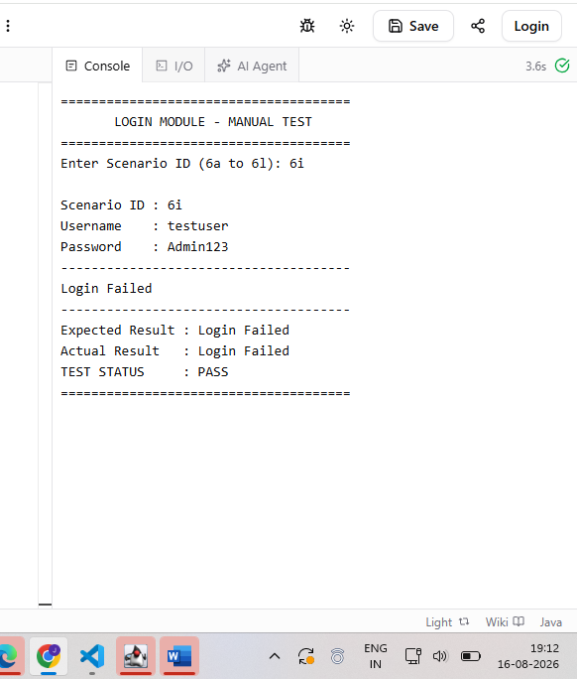

Scenario 6j

Scenario ID: 6j

Scenario: Login with Different Invalid Password

Test Steps:

1.Open the Java Login application.
2.Enter Scenario ID 6j.
3.Enter a different invalid password.
4.Run the test.

Test Input:

Username: admin, Password: Test@123

Expected Result:

Login Failed should be displayed.

Actual Result:

Login Failed displayed.

Status:

PASS

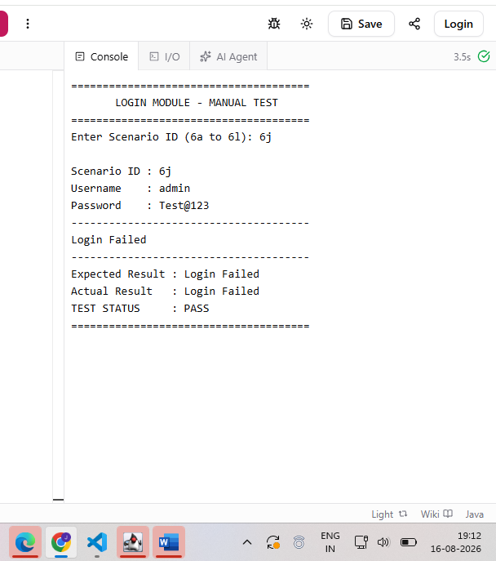

Scenario 6k

Scenario ID: 6k

Scenario: Verify Login Success Message

Test Steps:
1.Open the Java Login application.
2.Enter Scenario ID 6k.
3.Enter valid username and password.
4.Run the test.

Verify the success message.

Test Input:

Username: admin, Password: Admin123

Expected Result:

Login Successful message should be displayed.

Actual Result:

Login Successful message displayed.

Status:

PASS

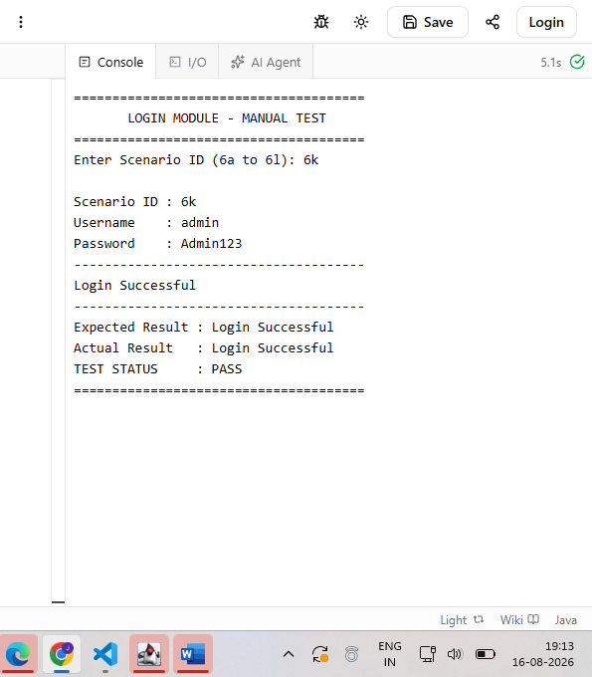

Scenario 6l

Scenario ID: 6l

Scenario: Verify Login Failed Message

Test Steps:

1.Open the Java Login application.
2.Enter Scenario ID 6l.
3.Enter valid username and invalid password.
4.Run the test.
5.Verify the failure message.

Test Input:

Username: admin, Password: Wrong123

Expected Result:

Login Failed message should be displayed.

Actual Result:

Login Failed message displayed.

Status:

PASS

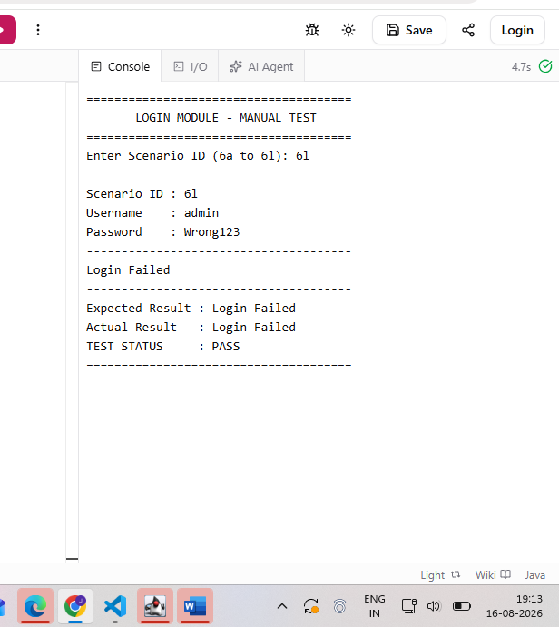

Test Execution Summary

Parameter | Result
Total Test Cases. | 12
Passed. | 12
Passed. | 12
Pass Percentage. | 100%
Overall Status. | PASS

Conclusion

The Login Module was successfully tested using valid, invalid and blank input conditions. All 12 test scenarios were executed successfully and the expected and actual results matched. Therefore, all test cases were marked as PASS.

